**Green Society Public School**

**D- 08**

**Ratnanagar-7, Sauraha, Chitwan**

**Second Terminal Examination-2082**

**Class: LKG Time: - 2 hrs. F.M.: 50**

**Sub: English**

|  |
| --- |
| **Name: Roll No.: Sec.:** |
| **­­­­­­­­­­­­ ________________ ______________ OBT.MARKS:**  **INVIGILATOR EXAMINER** |

**1. Make 2/2 words from the given letters. (4)**



B =



F =

**2. Tick (√) the correct spelling and cross (×) the wrong spelling. (4)**

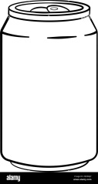

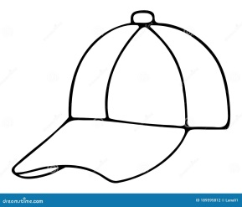 cap can

cat cot

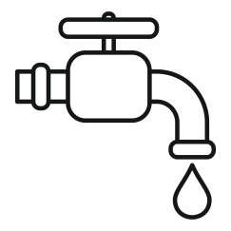

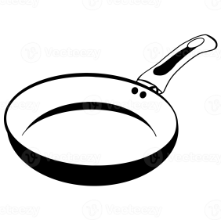 tub pen

tap pan

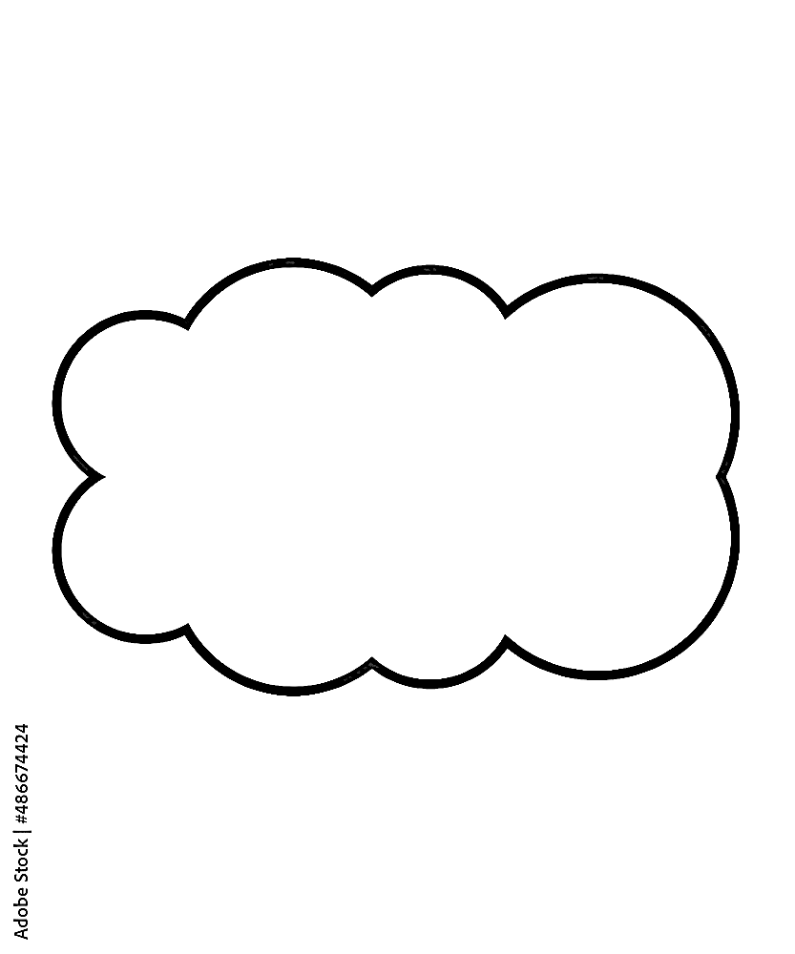**3. Circle ‘ed’ family words. (5)**

bed lap fed bat

fan hen rat ted

wed red can

**4. What comes after? (5)**

d _______ m _______ f _______

r _______ i _______

**5. What comes before? (5)**

_______ c _______ o _______ z

_______ h _______ u

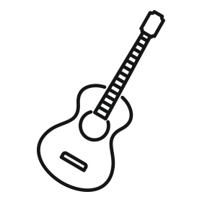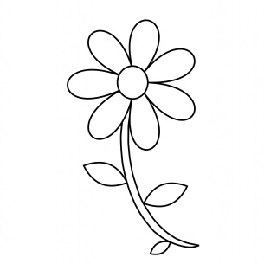**6. Write the first letter of the given pictures. (5)**

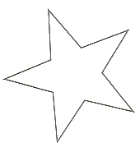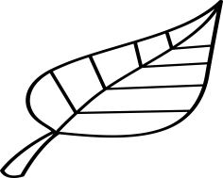

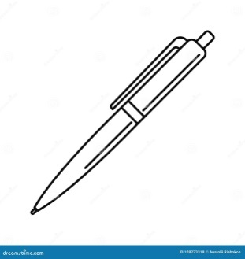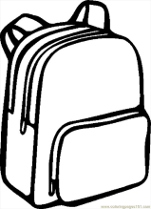**7. Write the missing letter in each word. (5)**

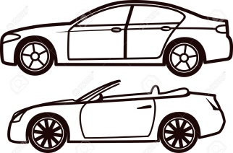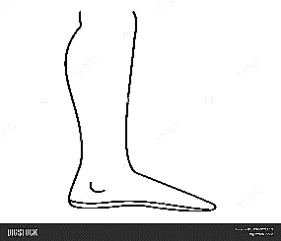

C _____ r

L _____ g

P _____ n

B _____ l l

B _____ g

**8. Write the vowel letters. (5)**

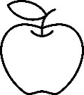

__________ __________

__________ __________

__________

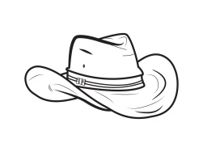**9. Match the given pictures. (6)**

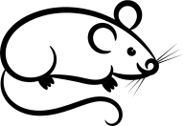rat

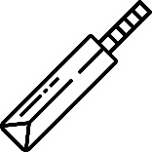 bat

hat

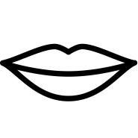 fan

pen

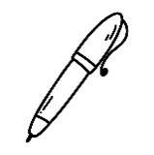 lip

**10. Make words. (6)**

______________

______________

______________

______________

______________

______________

**The End**